TTXSDK-IOS documentation

I. Preparation before integration

<https://github.com/tongtianxing/ios_cmsv6demo> ,Download demo. Get TTXSDK.framework.zip, unzip

2. Integrate into your project

Import TTXSDK.framework into the project, and then ensure that "Framework Search Paths" and "User Header Search Paths" are properly configured in the "Search Path" of "Build Setting" in "TARGETS".

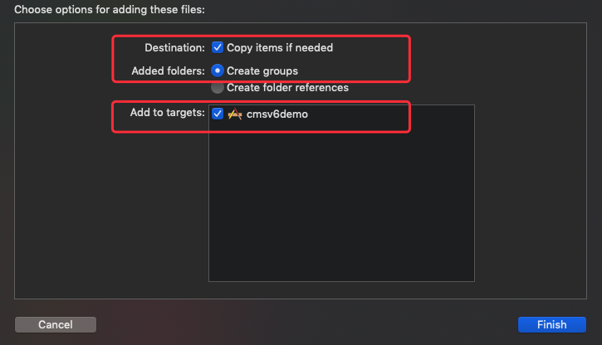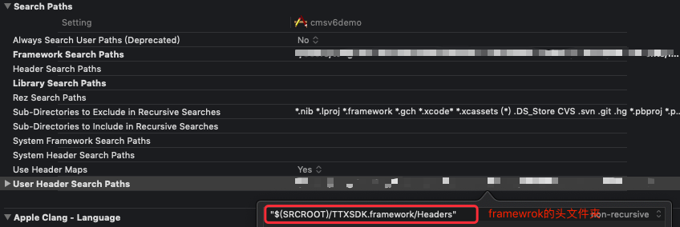

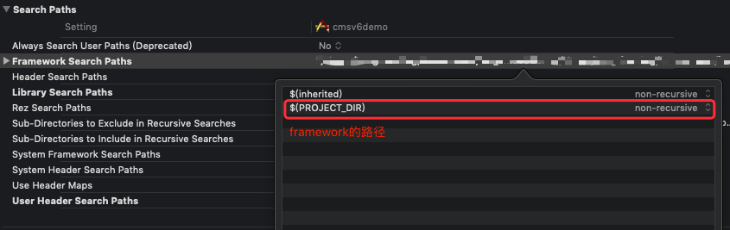

3. Add a dependency library

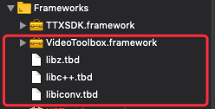

API interface

Login through the login interface of the web development interface document, and obtain vehicle information. Then configure it through TTXSDKPrepare.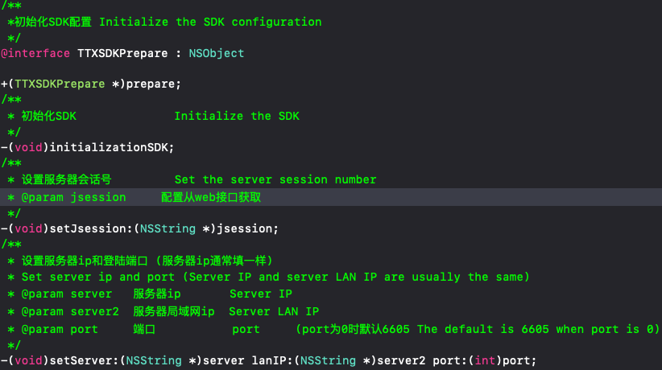

Live video

Live video with TTXRealVideo instanceB27CF0CC-6963-4B53-97CC-683752D45BDE.png

After the parameters are configured, the video preview is turned on, as well as the sound playback video function and so on.

Practical examples can be found in cmsv6demo

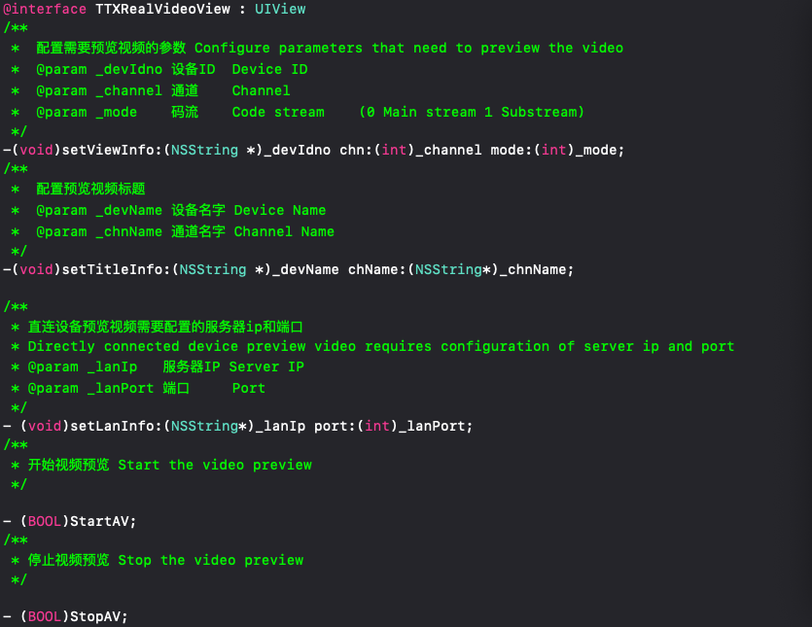

Talkback

Talkback using the TTXTalkback instance6.png

Configure the device ID of the talkback7.png

Practical examples can be found in cmsv6demo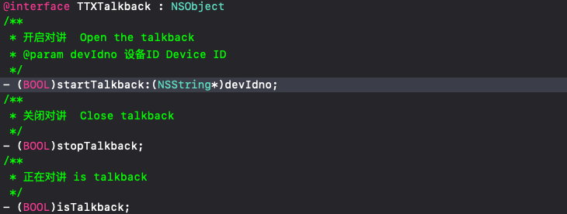

Playback

Use TTXPlaybackSearch instance to search for playback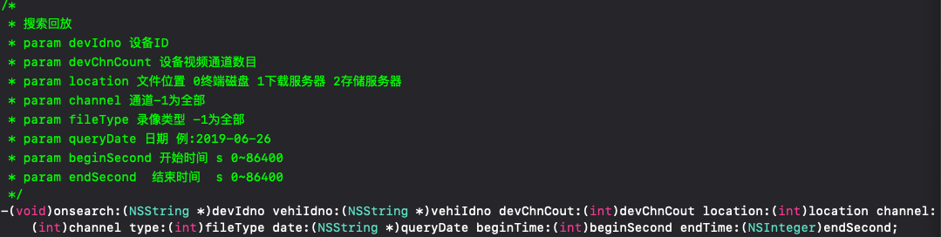

Callback returns an array of TTXDeviceSearchModel instances

Play playback using the TTXPlaybackView instance.

TTXPlaybackView includes playback pause adjustment progress and other functions, you can use this class to customize your own player. You can also use the player instance written by TTXPlaybackVideoController in our cmsv6demo.

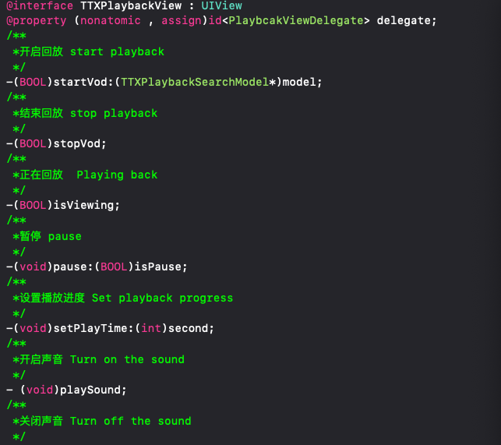

Playback Download

To use the PBDownload instance to perform the download operation, you need to configure the local cache key first, which is used to cache unfinished tasks and distinguish different server logins. Obtain cached tasks.

+(void)setCacheDictKey:(NSString\*)key;

+(NSMutableDictionary\*)getCacheDict;

Then configure the corresponding TTXPlaybackSearchModel and use it to download.

-(void)configPBDownloadWithModel:(TTXPlaybackSearchModel\*)model;

-(void)downloadPlaybackWithModel:(TTXPlaybackSearchModel\*)model hasUndone:(BOOL)has;

Can monitor the download success

static NSString \* const NSNotificationPbDownloadSuccess = @"NSNotificationPbDownloadSuccess";

Can be configured.Get download progress and speed

@property (nonatomic , copy)DownChangeBlock downChangeBlock; //下载进度更新block

Stop downloading and remove from local task

-(void)stopDownload;

Resume the breakpoint and need to be processed when exiting

-(void)stopDownloadWithPause;

What you need to do when downloading again.

-(BOOL)renewUndoneDownloadWithModel:(TTXPlaybackSearchModel\*)model;

For actual usage examples, you can check cmsv6demo

F&A:You need to be able to view the normal playback to download, there may be some devices that have abnormal time after downloading, which needs feedback to solve.

Device

Device search via TTXDeviceSearch instance

Use the method to open the search, return the search result through the callback (may be empty). Search for an instance array containing TTXDeviceSearchModel. The playback device preview video is also implemented by TTXRealVideo. For the implementation process, please refer to the DeviceSearchView class of cmsv6demo.

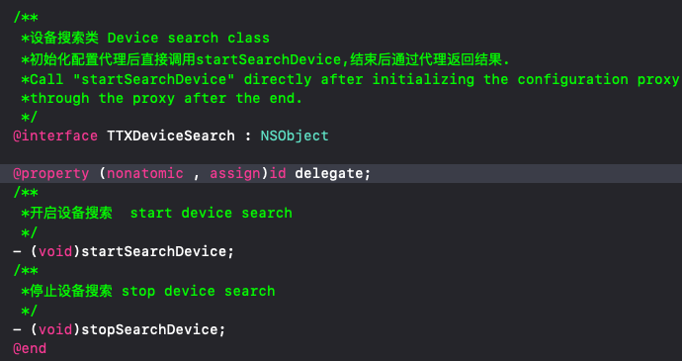

Rights Profile

The permission configuration is configured in the project's info.plist file.

If you use the intercom function, add the corresponding configuration item in info.plist.

Privacy - Microphone Usage Description microphone

If you use video or play back screenshots and videos

Privacy - Photo Library Additions Usage Description Album

The following is the cmsv6demo sample configuration.

